Palau
Country Infrastructure Profile

Country Facts |  | Key Statistics
Official name of country | Republic of Palau | Land area (km²) | 444¹
Capital | Ngerulmud | Exclusive economic zone (km²) | 603 978¹
Government and legal status | Presidential republic in free association with the United States | Population (2019 estimate) | 20 000*
Head of state | President Surangel Whipps Jr | Population density (persons/km) (2019) | 39*
Head of government | President Surangle Whipps Jr | Population growth (% annual change) (2014-2019) | 2%*
Official languages | English and Palauan | Urban population (% of total population) (2019) | 80.47%#
Official currency | United States Dollar | GDP (USD million) (2019) | 500*
Memberships | 1983 – Pacific Community (SPC)  1994 – United Nations  1994 – Independence  1995 – Pacific Forum Secretariat (PIF)  1995 – International Civil Aviation Organisation (ICAO)  2011 – International Maritime Organisation (IMO)  2013 – PRIF | GNI per capita (USD) (2018) | 17 280*
 |  | Proportion of population living below the national poverty line (2018) | --
 |  | Overseas development assistance for infrastructure (USD million) (2018) | 1.1*

Source: ¹ SPC members details https://www.spc.int/our-members/palau/details (accessed 17 July 2020); *Asian Development Bank, Basic 2020 Statistics, https://www.adb.org/mobile/basic-statistics-2020/ (accessed 17 July 2020); # World Bank, data, https://data.worldbank.org/indicator/SP.URB.TOTL.IN.ZS?locations=PW&view=chart (accessed 17 July 2020)

Map of Palau
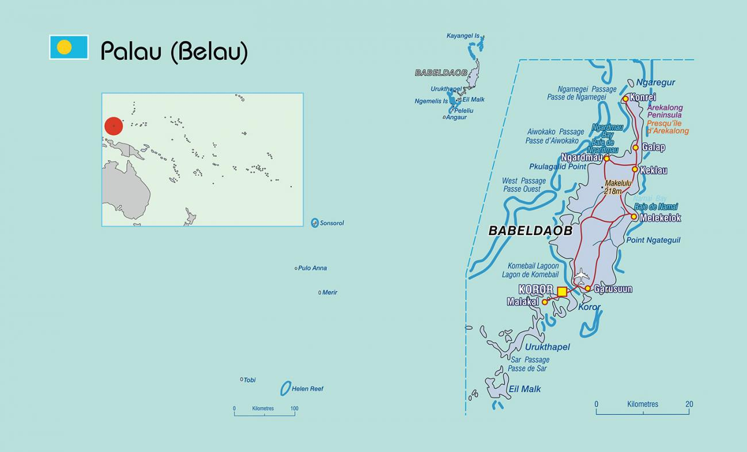
Source: https://www.spc.int/our-members/palau/details (accessed 17 July 2020)

Access and Infrastructure Indicators
Telecommunication  Proportion of population covered by mobile network (2G) (2018) 98.0%*  Proportion of population covered by mobile network (3G) (2018) 88.0%*  Proportion of population covered by mobile network (LTE/WiMAX) (2018) --  Water & Sanitation  Proportion of population using safely managed drinking water services (2017) 99.0%*  Proportion of population using safely managed sanitation services, including a hand-washing facility with soap and water (2017) 99.6%*  Percentage of population using at least basic sanitation services (2017) 100%#  Percentage of population using at least basic drinking services (2017) 100%# | Energy  Proportion of population with access to electricity (2017) 100%*  Renewable energy share in the total final energy consumption (2017) 0.1%*  Average annual mean of particulate matter of 2.5 microns in diameter or smaller levels in urban areas (ug/m³) 12.4*  CO₂ emission (metric tons/per capita) (2014) 14.77#  Transport^  International airport: 1 – Roman Tmetuchl International Airport (Palau International Airport)  Number of international airports 1  Total road network (km) 121  Paved road network as % of total network --  Number of international ports 1  Climate Resilience- related Risk Indexes⁺  INFORM natural hazard index 3.2  Physical exposure to earthquake 0.1  Physical exposure to flood 0.1  Physical exposure to tsunami 7.7  Physical exposure to tropical cyclones 4.9
Source: *Asian Development Bank, Basic 2020 Statistics, https://www.adb.org/mobile/basic-statistics-2020/ (accessed 17 July 2020)
# World Bank, data, https://data.worldbank.org/country/palau?view=chart (accessed 17 July 2020); ^ All transport indicators from the Pacific Region Infrastructure Facility, Pacific Infrastructure Performance Indicators (PIPI), 2016, www.dlca.logcluster.org/display/public/DLCA/2.3+Palau+Road+Network, ⁺European Union, INFORM Index for Risk Management, 2020. The risk score ranges from 0-10, where 10 is the highest risk. -- data not available for 2012-2019

Key Development Policies

- | Pathway to 2030 – progressing with Our Past Toward a Resilient, Sustainable and Equitable Future – 1st Voluntary National Review on the SDGs | 2019
- | Palau Climate Change Profile | 2019
- | The Republic of Palau Revised National Biodiversity Strategy and Action Plan 2015-2025 | 2016
- | Palau Responsible Tourism Policy Framework 2017-2021 | 2016
- | National Disaster Risk Management Framework 2010 (amended 2016) | 2016
- | Palau Intended Nationally Determined Contribution | 2015
- | Palau Climate Change Policy – for Climate and Disaster Resilient Low Emissions Development 2015 | 2015
- | Republic of Palau National Energy Policy | 2010

